Appendix 1 – Goericke Lab and UMCES HPLC intercomparison results
In 2023, CCE-LTER conducted extensive pigment comparisons using High-Performance Liquid Chromatography (HPLC) pigment analysis. Samples processed in both the Goericke Laboratory at Scripps Institution of Oceanography (UCSD) and the Horn Point Analytical Laboratory (UMCES) were used to investigate the intercomparability of a variety of chlorophyll, xanthophyll, and carotenoid pigments. Samples were obtained from the CCE Process Cruise P2107 (July-August 2021), CalCOFI cruise 2014-02 (Feb 2014) and CalCOFI cruise 2014-04 (April 2014). Process Cruise P2107 GFF HPLC samples were divided in half and each half was processed using in-house methods developed by each lab. The CalCOFI HPLC samples were extracted using the Goericke method and analyzed in both labs.

Figure 1 below shows a comparison between total Chlorophyll a measured by each laboratory and measured fluorometrically at sea using the acidification method. These results show good agreement between the results of the two labs for total Chlorophyll a analyses. Figures 2 – 5 show results for additional pigments. For each pigment, we show a pigment-pigment plot on the left to compare absolute concentrations estimated by the two labs. This plot also includes statistical information, specifically Pearson’s correlation and the average proportional bias. We note, however, that these statistics can often be misleading due to the differing detection limits (and values reported when pigments are below detection limits) for each laboratory. On the right in each plot, we show a plot that compares the ratio of the respective pigment to total Chlorophyll a, as measured in each lab. Based on these results we conclude that results for the following pigments are reasonably comparable between labs: Chl a, Divinyl Chl a, Chl b, Chl c (although Chl c values are slightly high at UMCES relative to Goericke), fucoxanthin, hexanoyloxyfucoxanthin, alloxanthin. For diadinoxanthin, peridinin, zeaxanthin, and butanoyloxyfucoxanthin the results of the comparison showed some distinct sample-to-sample differences between labs, but no distinct biases. Neoxanthin and prasinoxanthin exhibited distinct differences between labs for samples run at both institutions, with both typically having higher values at UMCES (if above the detection limit). We also compared the histograms for all mixed-layer (15 m) samples run from each lab (Figure 6). These are not paired samples, so mismatches could indicate differences between processing in each lab or actual changes in the timeseries (Goericke Lab samples are mostly pre-2014; UMCES samples are mostly post-2014). This analysis suggested potential issues with hexanoyloxyfucoxanthin and butanoyloxyfucoxanthin. All of these plots can be generated from data contained in this dataset. We recommend that investigators who use this data for assessing long-term changes carefully investigate the sensitivity of their results to the change in the laboratory of analysis.

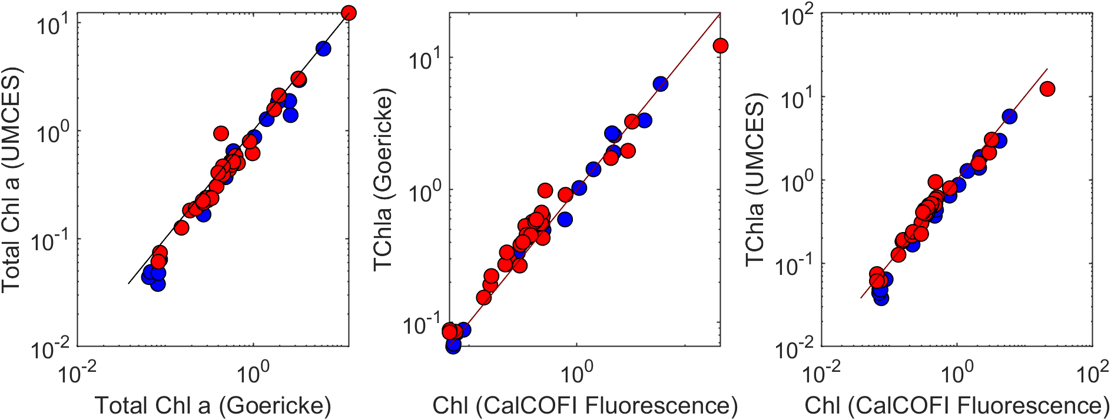
Figure 1 – Total Chlorophyll a (TChla) comparisons. Panel a shows the comparison between samples run at Horn Point Laboratory (UMCES) and the Goericke Lab (UCSD). Blue samples are from CCE Process Cruise P2107. Blue Samples are from CalCOFI cruises 2014-02 and 2014-04. Panels b and c show comparisons of the HPLC-derived TChla from the Goericke and UMCES labs (respectively) to TChla measured by a fluorometer at sea using the acidification method.
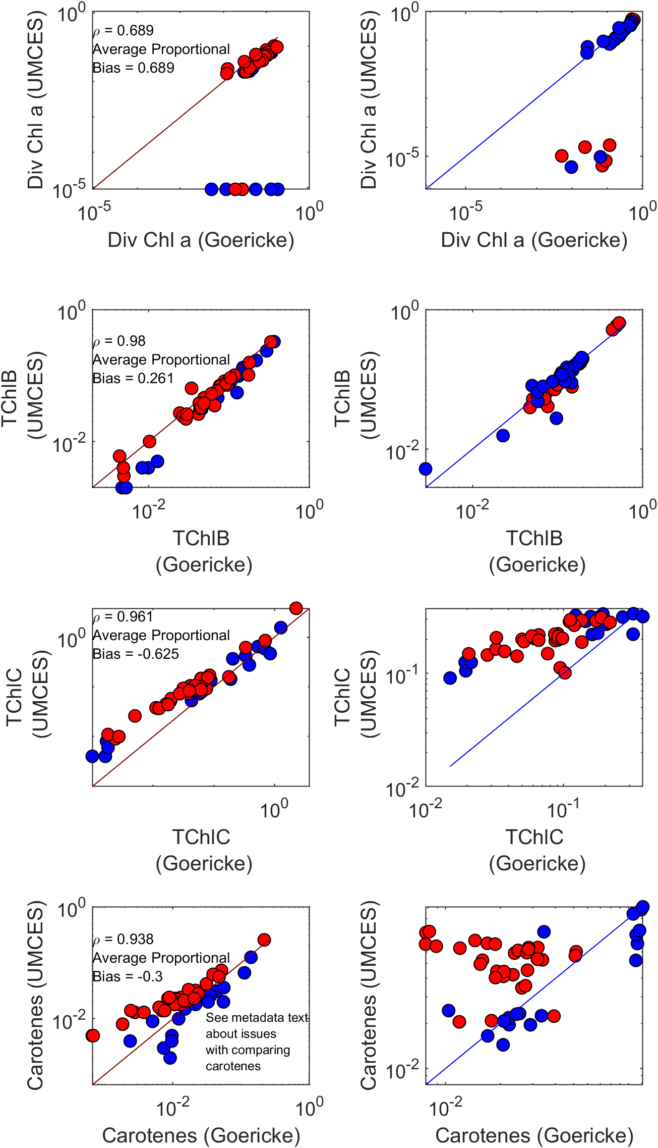
Fig. 2 – Comparisons between pigments measured in the Goericke and UMCES labs. Panels on the left are pigment-pigment comparisons. Pearson’s correlations and average proportional biomass are printed on each panel. Panels on the right show ratios of pigments to TChla. From top to bottom pigments are divinyl chlorophyll a, total chlorophyll b, total chlorophyll c, and carotenes.

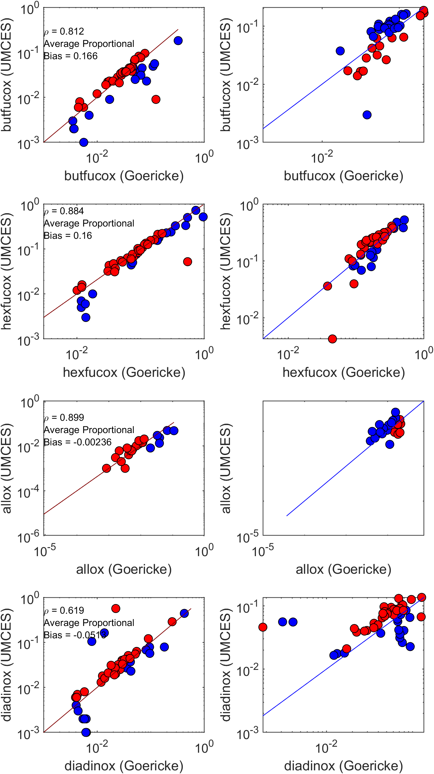
Fig. 3 – Comparisons between pigments measured in the Goericke and UMCES labs. Panels on the left are pigment-pigment comparisons. Pearson’s correlations and average proportional biomass are printed on each panel. Panels on the right show ratios of pigments to TChla. From top to bottom pigments are butanoyloxyfucoxanthin, hexanoyloxyfucoxanthin, alloxanthin, and diadinoxanthin.
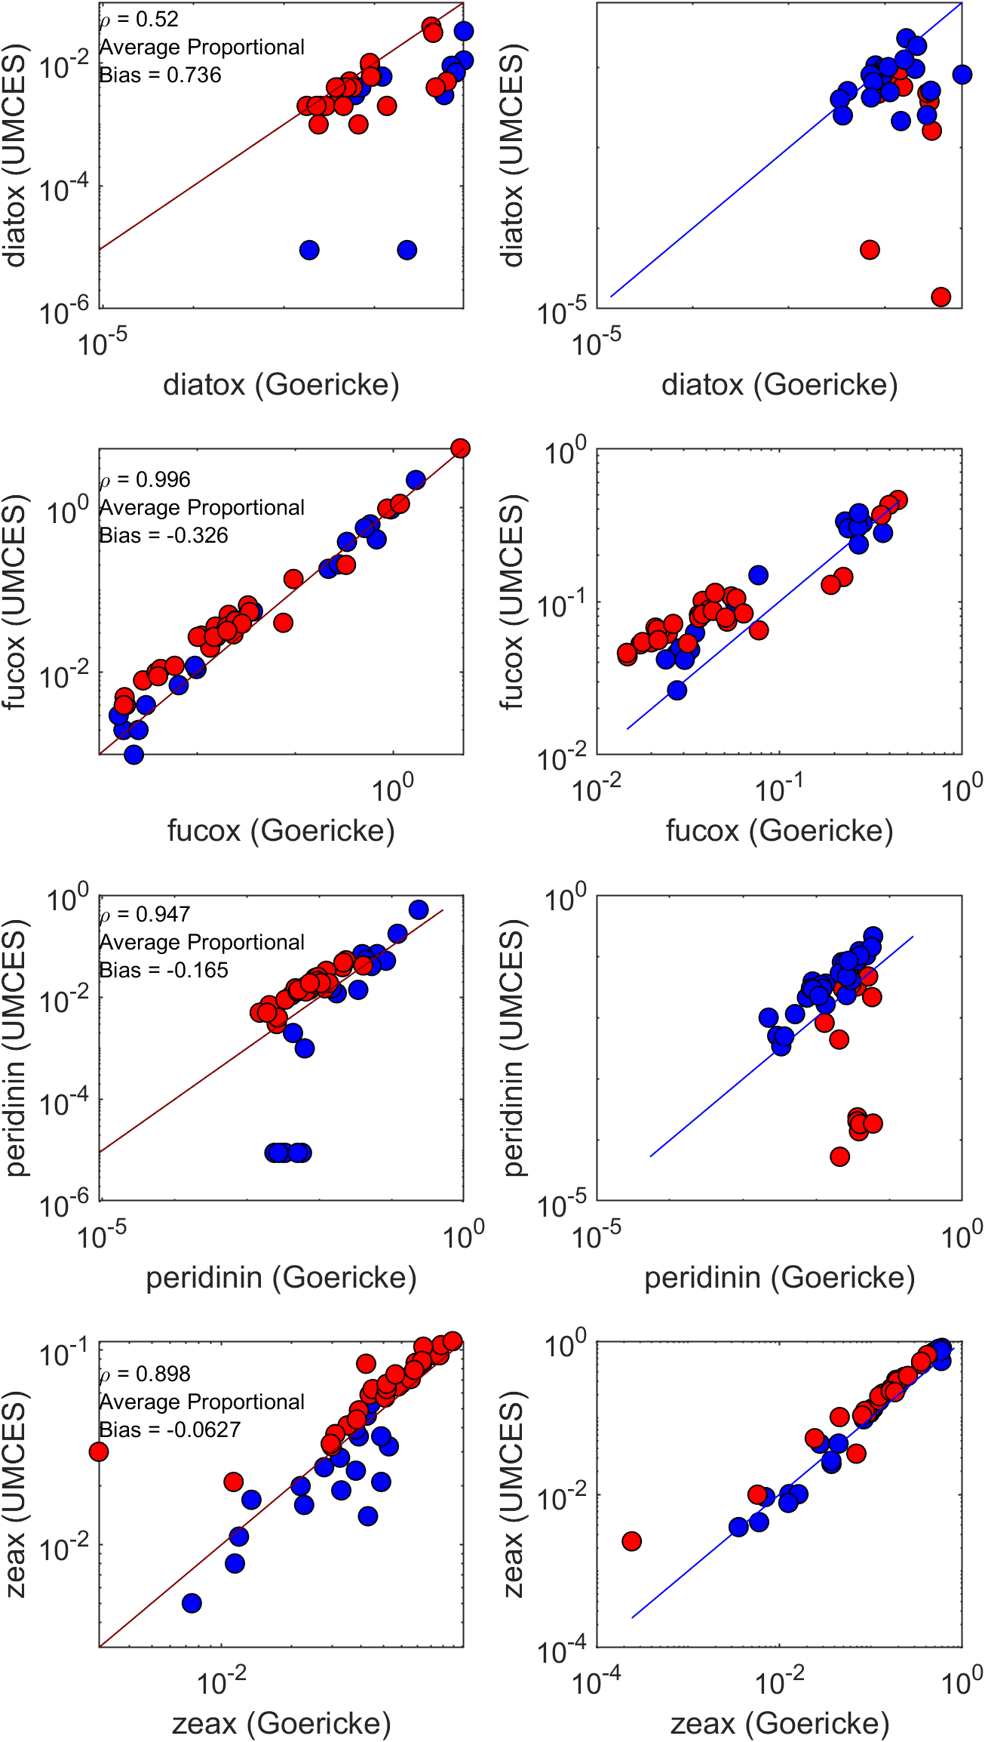
Fig. 4 – Comparisons between pigments measured in the Goericke and UMCES labs. Panels on the left are pigment-pigment comparisons. Pearson’s correlations and average proportional biomass are printed on each panel. Panels on the right show ratios of pigments to TChla. From top to bottom pigments are diatoxanthin, fucoxanthin, peridinin, and zeaxanthin.

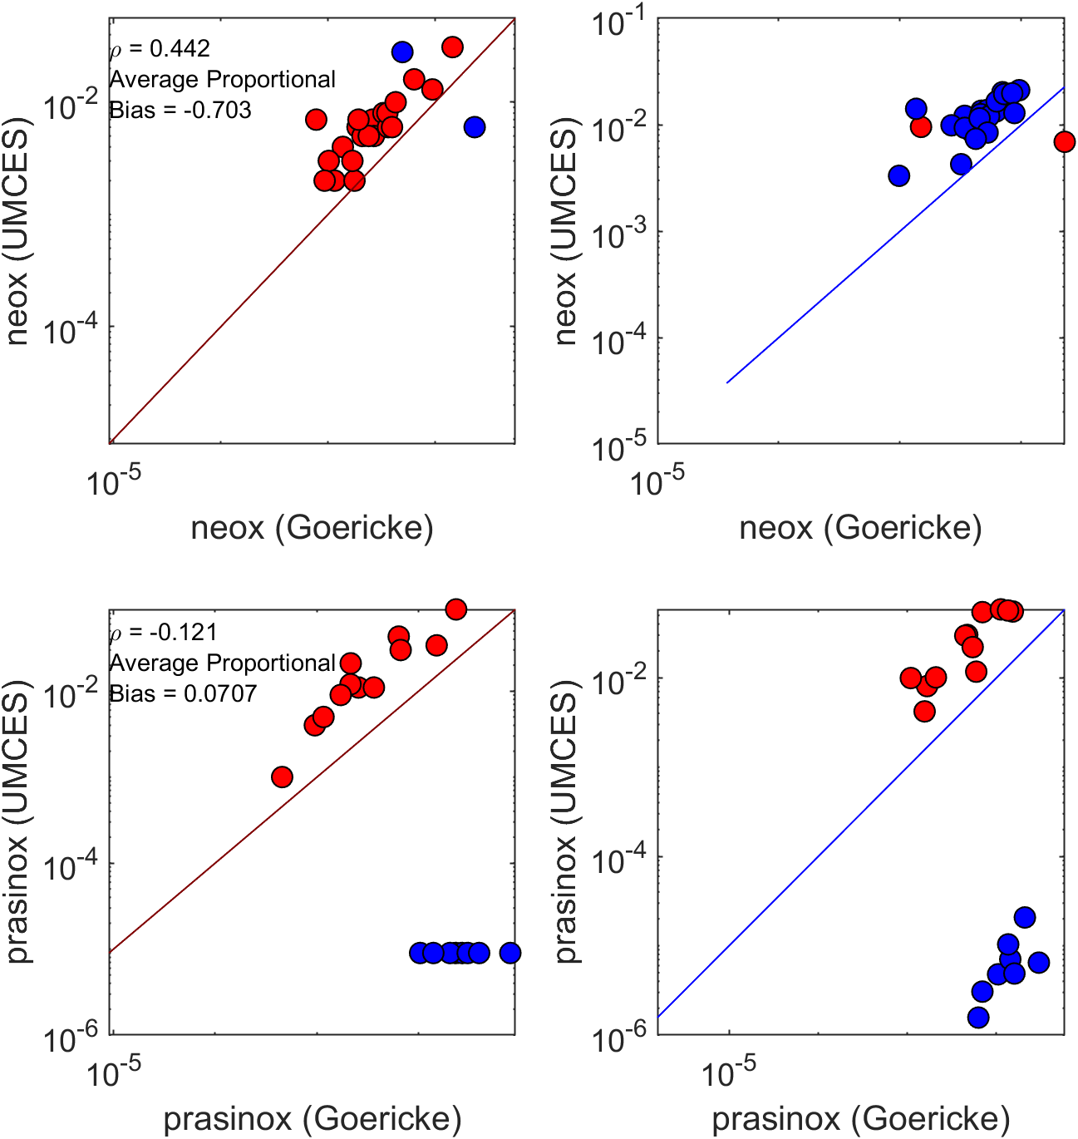
Fig. 5 – Comparisons between pigments measured in the Goericke and UMCES labs. Panels on the left are pigment-pigment comparisons. Pearson’s correlations and average proportional biomass are printed on each panel. Panels on the right show ratios of pigments to TChla. From top to bottom pigments are neoxanthin and prasinoxanthin.

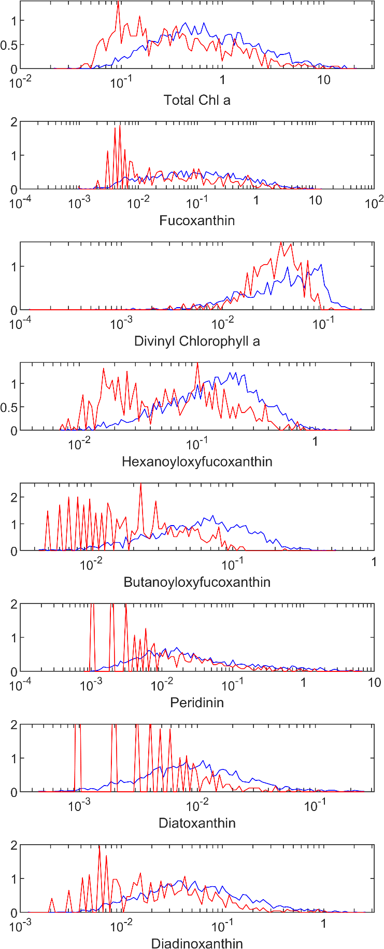
Fig. 6 – Histograms comparing the mixed layer (<15 m) pigment concentrations measured at UMCES (red) or in the Goericke lab (blue). Note that these are not based on paired samples.
Peloquin, J. and others 2013. The MAREDAT global database of high-performance liquid chromatography marine pigment measurements. Earth Syst. Sci. Data 5: 109-123.

